**ACADEMIC QUALIFICATIONS/TRAINING**

* African Fellow- Academic Fellowship award at the Institute for Advanced Studies in the Humanities (IASH), University of Edinburgh, United Kingdom, from 1 September to 30 November, 2019.
* **Tuning Online Course on “Course Design for Outcome Based Learning**

**in Higher Education”,** Tuning Academy, University of Deusto, Spain

October, 2017

* Coordinated a team of academics from Nnamdi Azikiwe University, Awka, who successfully completed the **Tuning Online Course on “Course Design for Outcome Based Learning in Higher Education”,** Organized by Tuning Academy, University of Deusto, Spain under the Tuning Africa II Initiative, January – October, 2017

**ACADEMIC /ADMINISTRATIVE EXPERIENCE AND PROFESSIONAL AFFILIATION**

Chairperson World Council for Curriculum and Instruction (WCCI) Awka Branch, Nigeria Chapter (2010- 2014, 2015 – 2018.

**OTHER EXPERIENCES**

* Executive Board Member (2019 – 2022). World Council for Curriculum and Instruction (WCCI), San Diego, California, U.S.A.
* Representative Nnamdi Azikiwe University Awka, at the Tuning Africa Project Phase 2, (2015 to February 2018). Project funded by the Commission of the European Union, sponsored by the African Union Commission and coordinated by the University of Deusto, Spain.
* Representative Nnamdi Azikiwe University Awka, at a Study on Research and PhD

Capacity in Sub-Saharan Africa. The study is coordinated by the African Network

For Internationalization of Education (ANIE) and Funded by the British Council and

German Academic Exchange Service (DAAD), from 18th February 2016 to 27th

February, 2017.

* Selected Panellist representing Africa at the World Council for Curriculum and

Instruction (WCCI) panel presentation, at the fifty ninth session of the United Nations’ (UN) Commission on the Status of Women (CSW 59) which took place at the UN headquarters in New York, from 9th to 20th March, 2015.

* Selected Panellist representing Africa at the World Council for Curriculum and

Instruction (WCCI) panel presentation, at the fifty ninth session of the United Nations’ (UN) Commission on the Status of Women (CSW 59) which took place at the UN headquarters in New York, from 9th to 20th March, 2015.

* One of the three members of the 2015 World Council for Curriculum and Instruction (WCCI) International Nominations and Elections Committee, October 2015. (The members are Joyce Pittman, Chair - USA; Teresita Agana, Member - Philippines and Lilian-Rita Akudolu, Member – Nigeria).
* Member, Anambra State Ministry of Education Committee on Girl – Child Education in Anambra State (2015- 2016).
* Selected Trainer in Research Methods in the 2009- 2010 Regional Training Workshops of the Educational Research Network for West and Central Africa (ERNWACA).
* Resource Person, UNICEF Marginal Budgeting for Bottlenecks (MBB) in Education workshop, Kaduna, Nigeria. (5th to 11th June, 2011).
* Nigeria Representative, Africa Higher Education Collaborative (AHEC) 2007-2009, organized by the Council for International Exchange of Scholars (CIES), Washington D.C. and Cairo.
* Member of National Technical Team (EDSI Technical Support Team) on the DFID/ UNICEF supported Development of States’ Education Strategic Plans (SESP) and State Education Strategic Operational Plans (SESOP) and UNICEF consultant for Niger, Ebonyi, Delta and Bayelsa States, Nigeria. (2008/2009, 2009/2010 and 2011/2012).

**PUBLISHED BOOKS AND CHAPTERS**

**BOOKS**

1. Akudolu, Lilian-Rita; Aremu, Ayotola and Peter-Lamuren, Esther (2011). **ICT in**

**Education.** Evans Professional Teacher-Education Series. Ibadan: Evans

Brothers (Nigeria Publishers) Limited

1. Akudolu, L-R.; Deme, A.; Nwufo, K.; and Nwokolo, H. (2007). **Basic Computer**

**Studies for Primary Schools.** Books 1 to 6, Onitsha, Africana First Publishers Limited

**CHAPTERS IN BOOKS**

1. Akudolu, L-R (2019). Language Education and Writing Skills. In U.M.O.Ivowi (Ed). **Educating for Functionality, 69 - 80.** Lagos: Foremost Educational Services Limited.

2. Akudolu, Lilian-Rita & Adeyemo, Kolawole Samuel (2018). Research and Phd Capacities in Sub-Saharan Africa: Nigeria Report. **International Higher Education.** Published by the British Council and German Academic Exchange service (DAAD). Accessed at www.britishcouncil.org/education/ihe or [www.daad.de](http://www.daad.de)

3. Akudolu, L-R & Emenyonu C.B. (2018). Mentoring: The Other Perceptions. In Mkpa, Anyanwu, Ijioma, Akudolu, Obih, Iwuji, Nzewi, Nwani, Obasi, Nwamuo and Zakaria (Eds). **Gender and Transformative Leadership 46 – 52.** Owerri: Hysab Printers & Publishers.

4.Akudolu, L-R. I. & Olibie, Eyiuche I. (2014). Balancing Educational Imbalances in Nigeria. In U. M. O. Ivowi (Ed). **Curriculum and Teaching in Nigeria 277 – 301.** Lagos: Foremost Educational Services Limited.

5.Akudolu, L-R. (2014). Strategies for Enhancing Access to and Retention of Female Students in University Education in Anambra State, Nigeria. In Onuka (Ed). **Analyzing Educational Issues: In Essays in Honour of Emeritus Professor Pai Obanya** Ibadan, Society for the Promotion of Academic and Research Excellence (SPARE).

6. Akudolu, L – R. & Okeke, J.O. (2013). Predicting Academic Success in Nigerian University using Ume and Post-Ume Scores: A Study of Nnamdi Azikiwe University, Awka, Anambra State, Nigeria. In Martins Fabunmi (Ed).**Explorations in Education: Selected Essays in Honour of Professor Pai Obanya, 113 – 124.**

Ibadan: His Lineage Publishing House.

7. Akudolu, L-R. (2012). Emerging Trends in Curriculum Development in Nigeria. In U.M.O. Ivowi and B.B. Akpan (Eds).**Education in Nigeria: From the Beginning to the Future 153- 166.** Lagos: Foremost Educational Services Limited.

8. Oanda, I. & Akudolu, L-R. (2010). Addressing Gender Inequality in Higher Education through Targeted Institutional Responses: Field Evidence from Kenya and Nigeria. In Sabine O’hara (Ed).**Higher Education in Africa: Equity, Access, Opportunity 69- 85.**New York: Institute of International Education.

9. Akudolu, L-R. (2010). Using the Internet for Research Purposes. In D.C. Ekpunobi, J.C.Eyisi and U.C.Okonkwo (Eds.).**Research methodology: The Basics 102-117.** Onitsha: EFS Allied Publishers Limited.

10. Akudolu, L-R. (2009). Liberal Education for Functional Coexistence in Society. In U.M.O. Ivowi (Ed.). **Education for Value 249- 259.** Lagos: The CIBN Press Limited.

**JOURNAL PUBLICATIONS**

1. Akudolu, L-R.I., Ugochukwu, S.E. & Olibie, E. I. (2017). Preparing University Students in Nigeria for Global Citizenship through Virtual Learning.  **International Journal of Curriculum and Instruction (IJCI). 9 (1).** Available online at ijci.wcci-international.org

2. Akudolu, Lilian-Rita & Umenyi, Doris C. (2016). Institutionalizing Culture of Peace in Basic Education through Appropriate Curriculum Implementation. **International Journal of Curriculum and Instruction (IJCI). 8 (1) 9 -21**

3. Akudolu, Lilian-Rita (2015). How Does Education Respond to the Needs of Contemporary Society? **Global Journal of Education, Volume 1, Spring 2015, 28 – 38.** Available online at http://www.uofriverside.com/wp-content/uploads/2015/10/2015-10-12-Global-Jounal-Education-Final-2.pdf

4. Esomonu, Akudolu,& Ezenwosu (2015). Effects of Team Teaching on Students’ Academic Achievement in English Language Comprehension. **IOSR Journal of Research & Method in Education (IOSR-JRME) e-ISSN: 2320–7388,p-ISSN: 2320–737X Volume 5, Issue 5 Ver. III** (Sep. - Oct. 2015), PP 06-12 Available online at www.iosrjournals.org DOI: 10.9790/7388-05530612 www.iosrjournals.org 6 | Page.

5. Akudolu, L-R (2015, Dec.). How Prepared are Teachers for the Implementation of Peace Education Curriculum? **Journal of Curriculum and Instruction, Vol.10 (2) 237 - 253**

6. Akudolu, L-R. & Olibie, E. I. (2013). Toward a Functional Citizenship Education Curriculum in Nigerian Colleges of Education for Sustainable Development in the 21st Century. **American International Journal of Contemporary Research, Vol. 3 (8) 95 -102.** Available at http://www.aijcrnet.com/journals/Vol_3_No_8_August_2013/11.pdf

**7.** Akudolu, L-R. and Olibie, E.I. (2013). Developing TVET Teachers for Meeting the Demands of Sustainable Development on Curriculum Tasks. **Scottish Journal of Arts, Social Sciences and Scientific Studies Vol. 11 (1) 87 - 98**

8. .Akudolu, L-R. (2012). Exploring Appropriate Pedagogical Designs for Optimizing E- Learning in Higher Education in Nigeria. **UNIZIK Orient Journal of Education Vol. 6 No. 1.**

9. Akudolu, L-R. (2011). The Formal, Non-formal and Informal Continuum in Peace Education Curriculum. .**Journal of the World Council for Curriculum and Instruction Nigeria Chapter Vol. 8 (1) 1 - 9.**

10. Ezenwosu, Ngozi & Akudolu, L-R. (2011). Developing Peace Education Curriculum in Nigeria: Team teaching as a Strategy. **Journal of the World Council for Curriculum and Instruction Nigeria Chapter Vol. 8 No. 2.**

11. Akudolu, L-R. (2010). A Curriculum Framework for Entrepreneurship Education in Nigeria. **UNIZIK Orient Journal of Education. Vol. 5 No.2**

12. Olibie, E. Ifeoma; Akudolu, Lilian-Rita Ifeoma; & Uzoechina, O. Gladys (2010). Relevance and Benefits of Virtual Learning to Higher Education. **East African Journal of Educational Research and Policy (EAJERP). Vol.4,137 –151.**

13. Akudolu, L-R. &Olibie, E. I. (2009*).* Head Teachers’ Curriculum and Instructional Leadership in Primary Education for All in Anambra State**. Journal of Curriculum and Instruction. Vol.7 (3) 105 -118.**

14. Akudolu, L-R. & Olibie, E. I. (2009). The Roles of Stakeholders in Enhancing Information and Communications Technology (ICT) Use in Secondary schools In Anambra State. **Nigerian Journal of Curriculum Studies. Vol. 16 (2) 244 - 252**

15. Olibie, E. I. & Akudolu, L-R.I. (2009). Creativity: A Blind Spot in Quality Teacher Education in Anambra State of Nigeria.  **African Research Review: An International Multi-Disciplinary Journal, Ethiopia. Vol. 3 (2) 308 -321.**

16. Akudolu, L-R (2008). Quest For Teacher Needed Competencies for Instructional Use of ICT: Views from European Union. **Nigerian Journal of Teacher Education and Teaching.Vol.4 (1) 9 -18.**

17. Akudolu, L-R, (2007). Investigating Strategies Nigerian Government Should Adopt for Promoting Distance Learning Through Information and Communications Technology (ICT) in Education: Views from European Union. ***Journal of Curriculum and Instruction. Vol. 6 (1) 89 - 100.***

18. Akudolu, L-R. & Olibie, E. (2007**).** Seeking Appropriate ICT Teaching Approach for Developing Teacher ICT Competencies: Views from European Union **.UNIZIK Orient Journal of Education Vol.3 (1) 33 - 38**

19. Akudolu, L-R (2007). Adequacy of Student-activity Component of Introductory

Technology Curriculum for Students’ Acquisition of Technological Literacy.

**Journal of Teacher Education and Teaching.Vol.3 No. 1.**

20. Akudolu, L-R (2006). Investigating Teacher Information and Communications Technology (ICT) Needed Competencies to Be Acquired From Continuing Professional Development Programmes (CPDP): Views from European Union. **The Educational Psychologist Vol. 3 No. 1**

21. Akudolu, L-R. (2006). Assessing Nigeria’s Quest to Bridge Digital Divide through the Provision of Information and Communication Technology (ICT) Facilities and Applications in Primary Schools. **Journal of Theoretical and Empirical Studies in Education Vol.1.**

**SOME EDITED WORK**

**EDITED WORK**

1. Akudolu, Lilian-Rita (2017). **International Journal of Educational Research and Development (IJERD), Vol.6. No. 1.**

2. Akudolu, L-R. (2016, July). **International Education Journal (INTEJ) Vol. 10 No. 1**

3. Akudolu, L-R. (2015, Dec.). **Journal of Curriculum and Instruction.Vol.10,**

**No 2.**

4. Akudolu, L-R. (2015, July). **Journal of Curriculum and Instruction.Vol.10, No 1.**

5. Akudolu, L-R. (2015, Dec.). **International Education Journal (INTEJ) Vol. 9 No. 1**

**COMPLETED FUNDED PROJECTS**

**1.** Akudolu, L-R (2017). Study on **Research and PhD Capacity in Sub-Saharan Afric**a (February 2016 to February 2017), coordinated by the African Network For Internationalization of Education (ANIE) and Funded by the British Council and German Academic Exchange Service (DAAD). The research study involved six countries; Ethiopia, Ghana, Kenya, Nigeria, Senegal and South Africa.

2. Akudolu, L-R (Principal investigator); Omenyi, Ada-Sam; Ogu, Okey; Esomonu, Nkechi and Nwankwo, CAN (2011). **Institutional Initiatives to Enhance Participation, Access, Retention and Success in African Higher Education: A Multi-Country Study on Good Practice to Inform Policy.** Project covered Kenya, Nigeria and South Africa and was sponsored by the Association of African Universities (AAU) under the Mobilizing Regional Capacity Initiatives program July 2010– 30th October 2011.

3. Akudolu, L-R. (2009). **Strategies for Enhancing Access to and Retention of**

**Females in Higher Education in Nigeria.** Sponsored project by Ford Foundations

Through Africa Higher Education Collaborative (AHEC ), USA

4. Ibrahim Oanda O. and Akudolu, L-R. (2009). **Widening Female Access and Participation in**

**African Higher Education through Targeted Institutional Policy Interventions; Field**

**Evidence from Kenya and Nigeria**. Research Funded by Ford Foundations USA through

AHEC

**REPORTS**

1. Akudolu, Lilian-Rita and Adeyemo, Kolawole Samuel (2018). **Research and PhD Capacities in Sub-Saharan Africa: Nigeria Report.** Part of overall study commissioned to the African Network for Internationalization of Education (ANIE) by The German Academic Exchange Service (DAAD) in partnership with the British Council.

2. Amazigo, Uche and Akudolu, Lilian-Rita (2015). **Girl-Child Education: Investment not Expenditure for Anambra State Development.** A Project Report submitted to the Governor of Anambra State on the Girl-Child Education Project.

**COMPLETED FUNDED PROJECTS**

**1.** Akudolu, L-R (2017). Study on **Research and PhD Capacity in Sub-Saharan Afric**a (February 2016 to February 2017), coordinated by the African Network For Internationalization of Education (ANIE) and Funded by the British Council and German Academic Exchange Service (DAAD). The research study involved six countries; Ethiopia, Ghana, Kenya, Nigeria, Senegal and South Africa.

2. Akudolu, L-R (Principal investigator); Omenyi, Ada-Sam; Ogu, Okey; Esomonu, Nkechi and Nwankwo, CAN (2011). **Institutional Initiatives to Enhance Participation, Access, Retention and Success in African Higher Education: A Multi-Country Study on Good Practice to Inform Policy.** Project covered Kenya, Nigeria and South Africa and was sponsored by the Association of African Universities (AAU) under the Mobilizing Regional Capacity Initiatives program July 2010– 30th October 2011.

3. Akudolu, L-R. (2009). **Strategies for Enhancing Access to and Retention of Females in Higher Education in Nigeria.** Sponsored project by Ford Foundations Through Africa Higher Education Collaborative (AHEC ), USA

4. Ibrahim Oanda O. and Akudolu, L-R. (2009). **Widening Female Access and Participation in African Higher Education through Targeted Institutional Policy Interventions; Field Evidence from Kenya and Nigeria**. Research Funded by Ford Foundations USA through AHEC

**OTHER ARTICLES AND CURRENT RESEARCH**

Please Delete the words in red (AND CURRENT RESEARCH)

**PUBLICATIONS IN CONFERENCE PROCEEDINGS**

1. Akudolu, L – R. & Umenyi, D.C. (2013). Comparison of Computer Assisted Instruction (CAI) and Teacher Directed Instruction (TDI) for Improving Secondary School Students Achievement in Food and Nutrition. In Bolarin, T.A & Unachukwu, G.C. (Eds). Education for all: Progress and Challenges. Proceedings of the 28th Congress of the Nigerian Academy of Education.

2. Olibie, E. I. & Akudolu, L-R. (2008). Empowering Secondary School Teachers for Teaching and Training in Information and Communications Technology (ICT). Proceedings of the 29thAnnual Convention and International Conference of Nigeria Association for Educational Media and Technology

3. Nwana, Rose- Eunice and Akudolu, L-R. (2002).Promotion and Retention of Igbo Girl-Child in Nigerian Secondary Schools: A Review of Igbo Tradition and The Contributions of the Teacher Librarian. Proceedings of the 12th International Conference of Women Engineers and Scientists on Women in a Knowledge- Based Society. Canada, Ottawa Congress Centre. Accessible At http://www.icwes12.org.

4. Akudolu, L-R (1994). Factors Motivating Adults to Learn the French Language: Implementation for Rural Development. In B.G. Nworgu (Ed).Education for Rural Development: A Publication of the Association for Promoting Quality Education in Nigeria (A.P.Q.E.N.).

5. Ogboona- Ohuche, E. & Akudolu, L-R.(1994). Gender Differentiation at the Secondary School Level in English Language..In Women Education and National Development, 15 – 22 Proceedings of the Nigerian Academy of Education.

**EVENTS AND COUNTRY VISITED FOR PROFESSIONAL WORK IN EDUCATION**

* **United Kingdom (UK), Edinburgh.** Did my African Fellowship programme at the Institute for Advanced Studies in the Humanities (IASH), University of Edinburgh, from 1 September to 30 November 2019.
* **Belgium, Brussels.** Attended the Fifth General Meeting of the Tuning Africa Project (Phase 11), from 13th to 15th November, 2017.
* **South Africa, Johannesburg**. Attended the Fourth General Meeting of the Tuning Africa Project (Phase 11), from 2nd to 6thApril, 2017
* **Ghana, Accra**. Attended the Third General Meeting of the Tuning Africa Project (Phase 11), from 17th to 21st October, 2016
* **Zambia, Lusaka.** Participated at the English Formation Workshop organized by the Secular Franciscan Order (OFS) at St. Bonaventure’ University College, Lusaka, from 22nd to 25th June 2016.
* **Ethiopia, Addis Ababa.** Attended the Second General Meeting of the Tuning Africa Project (Phase 11), from 29th February to 2nd March, 2016
* **Kenya, Nairobi.** Attended the Kick-Off meeting organized by the African Network for Internationalization of Education (ANIE) on Research and PHD Capacity in Sub-Saharan Africa, a multi-country project funded by British Council and German Exchange Service (DAAD), from 17th February, 2016to 19th February, 2016.
* **Egypt, Cairo**. Attended the First General Meeting of TUNING Africa Project Phase 2, Coordinated by the University of Deusto, Spain, and Funded by Commission of the European Union and sponsored by the African Union Commission. Cairo, Egypt from 12th to 14th October, 2015
* **United States of America, New York**. Attended the United Nations 59th Commission on the Status of Women (CSW 59), from 9th to 20th March, 2015.
* **United States of America, California**. Attended the 16th World Conference in Education of the World Council for Curriculum and Instruction (WCCI), from 17th to 24th August, 2014
* **United States of America, Ontario.** Attended the Global Conference on Education Organized by University of Riverside, Ontario, from 8th to9th August, 2014.

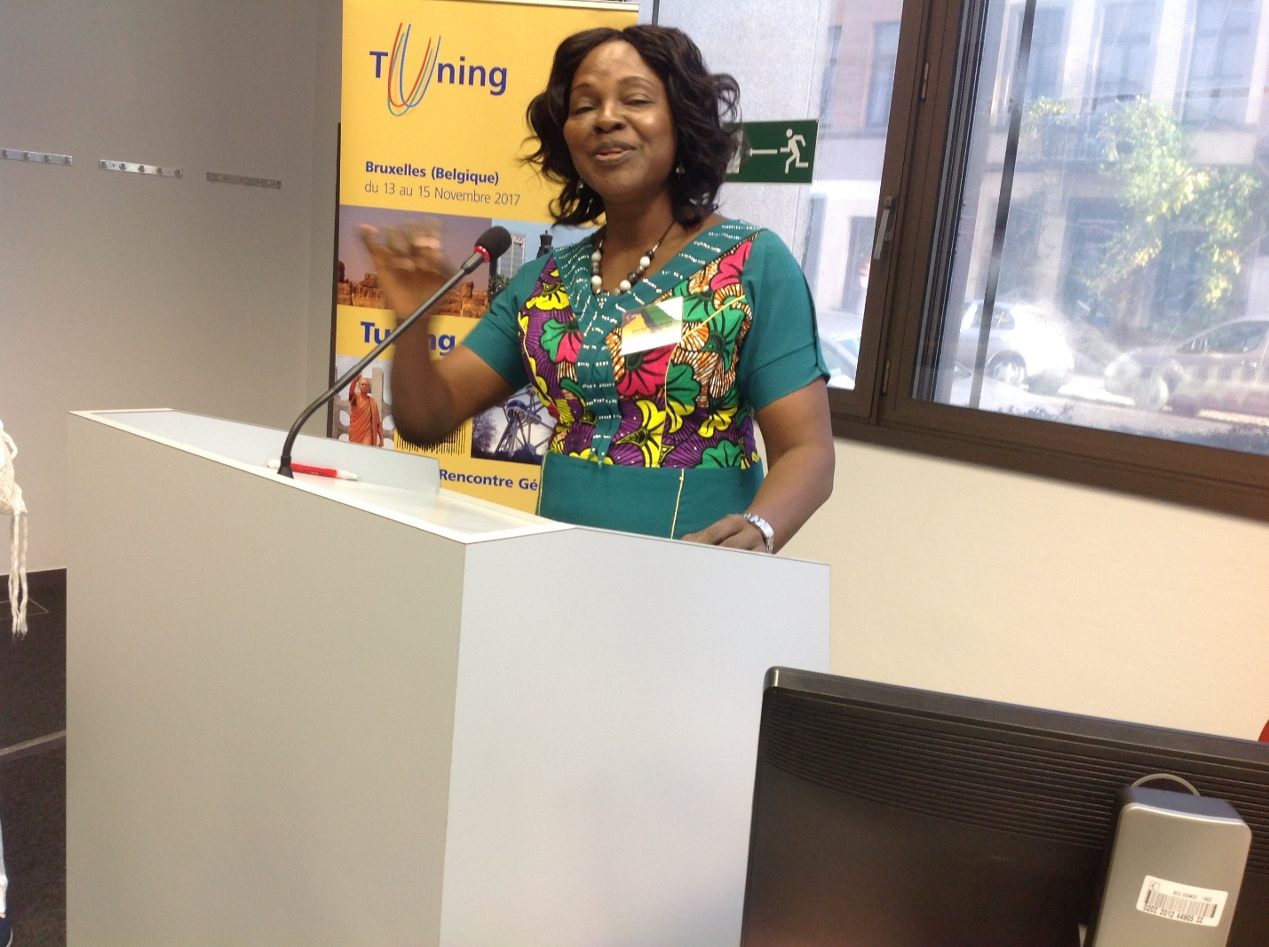

Lilian-Rita making a presentation at the general meeting of the TUNING Africa Project (phase II) at Belgium, Brussels, 2017

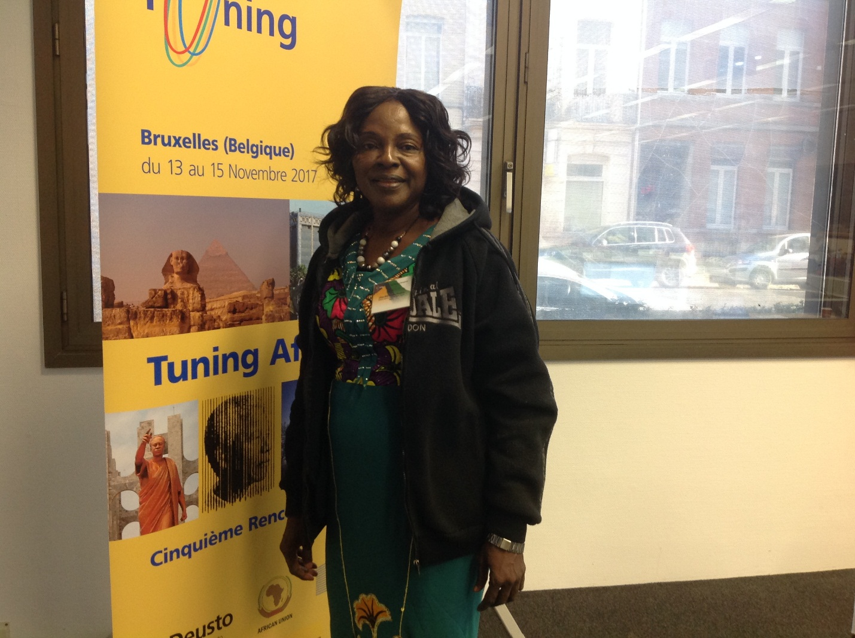

At Belgium, Brussels, 2017

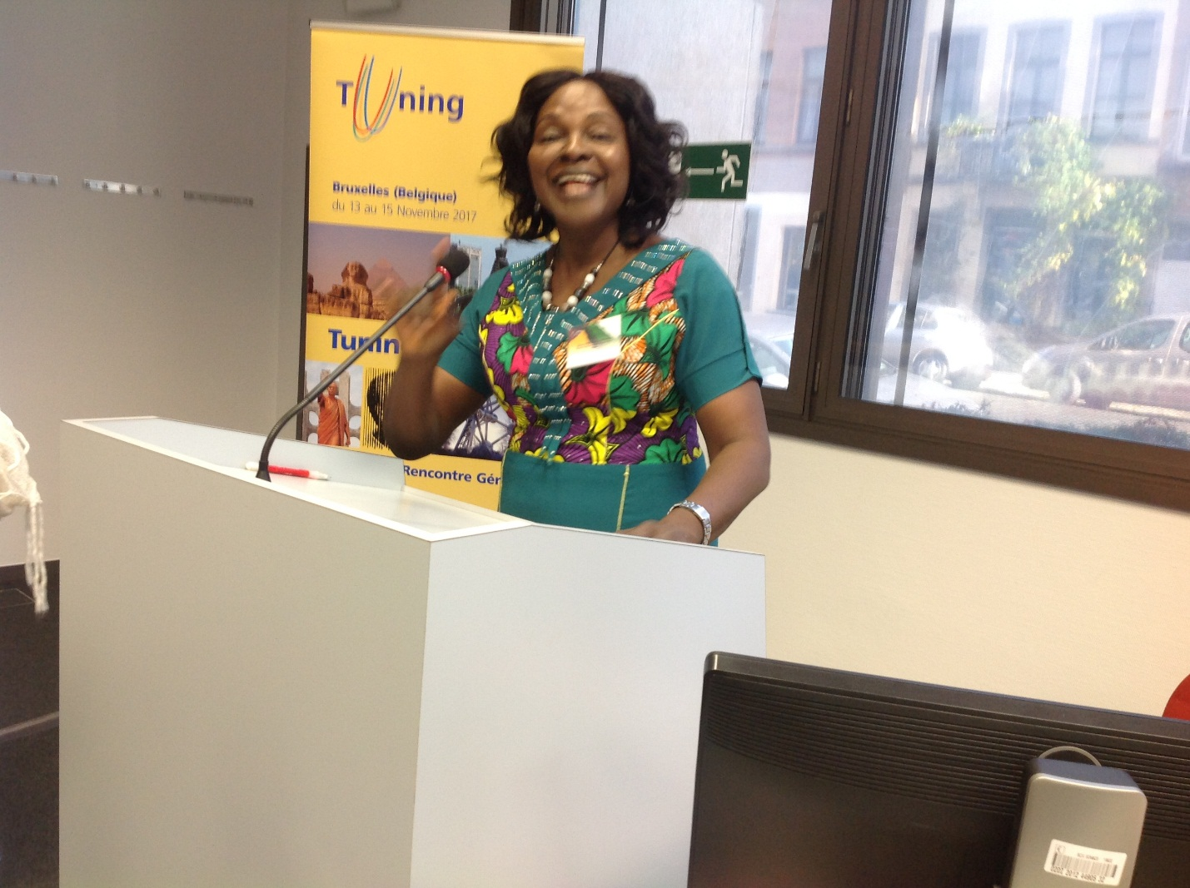

Lilian-Rita making a presentation at the general meeting of the TUNING Africa Project (phase II) at Belgium, Brussels, 2017

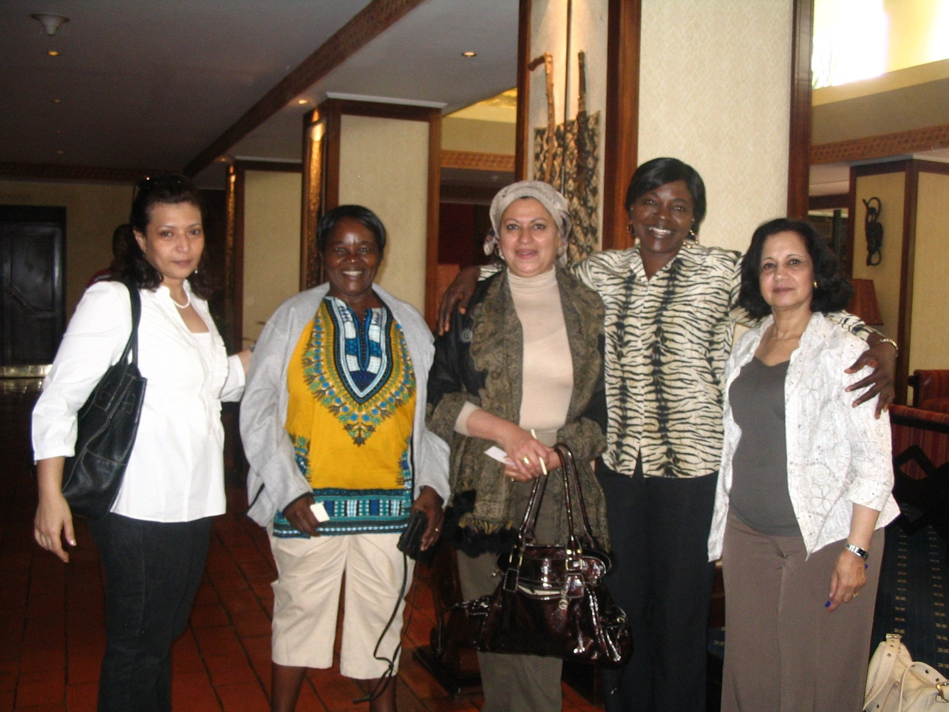

Lilian-Rita with her academic colleagues in Kenya at the meeting organized by the African Network for Internationalization of Education (ANIE) on Research and PHD Capacity in Sub-Saharan Africa, a multi-country project funded by British Council and German Exchange Service (DAAD).

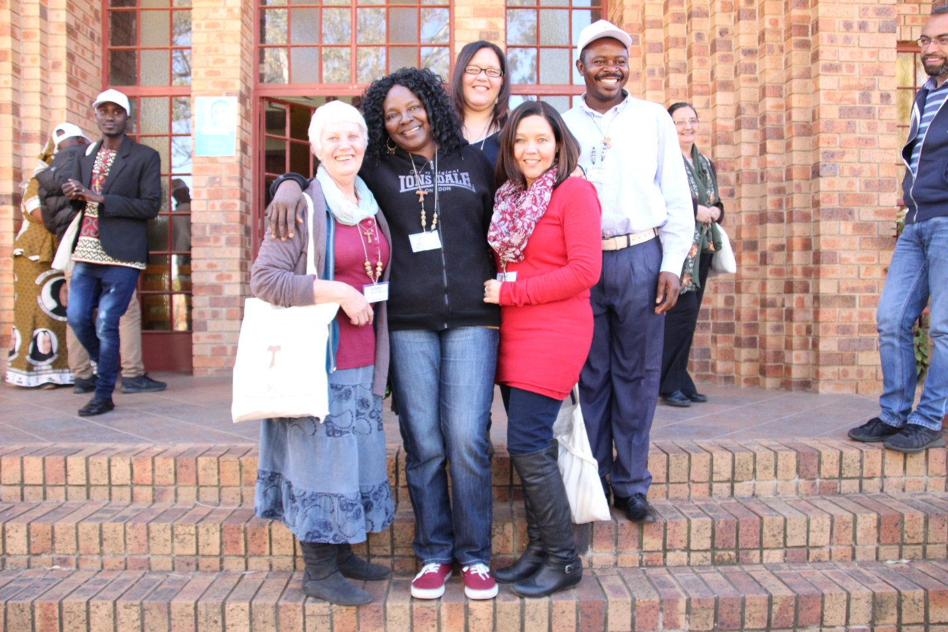

**Lilian-Rita with her friends in South Africa**

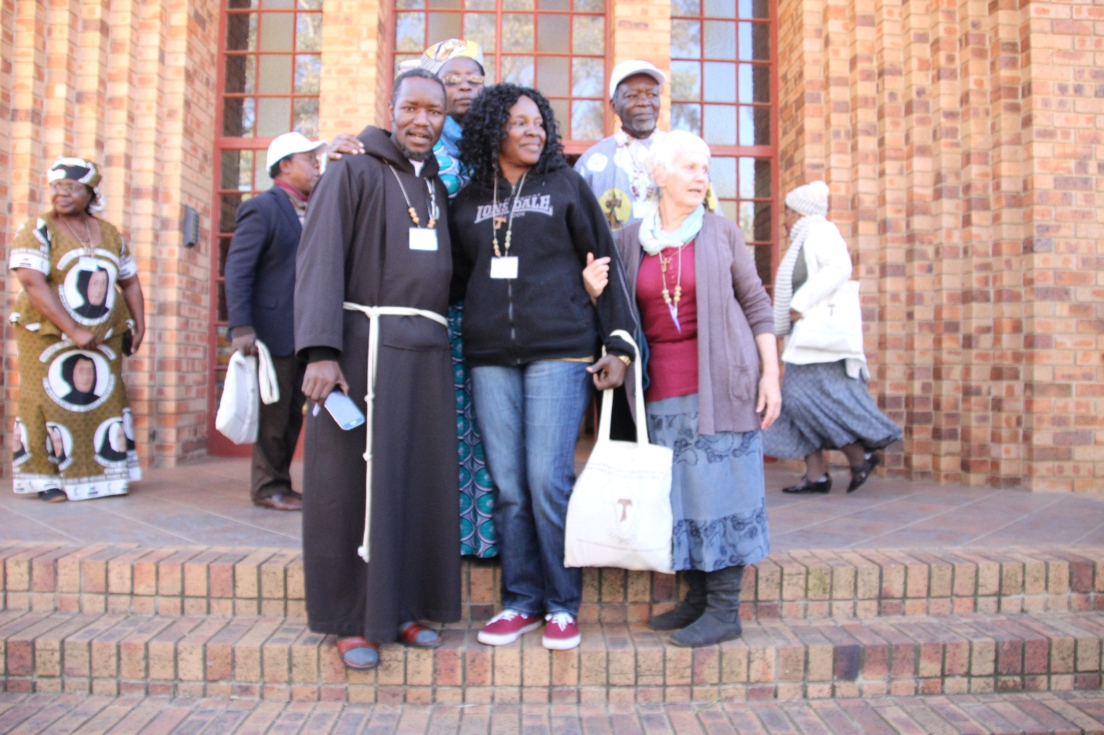

**Lilian-Rita with her friends in South Africa**

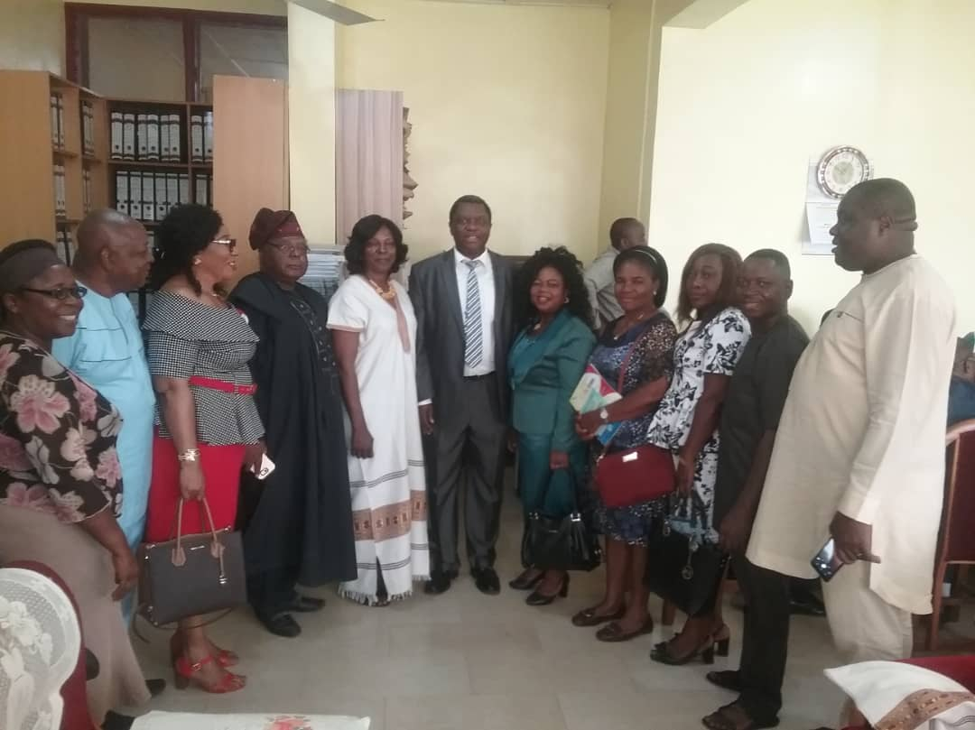

**Lilian-Rita (fifth from left) with the board members of World Council for Curriculum and Instruction Nigerian Chapter pose with Prof. Charles Esimone (Centre), the Vice Chancellor Nnamdi Azikiwe University Awka.**

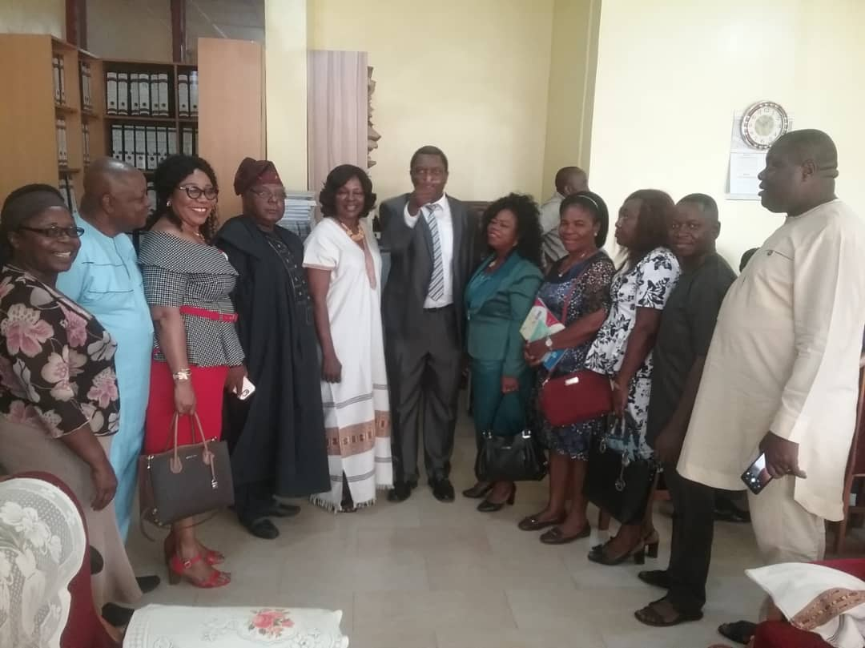

**Lilian-Rita (fifth from left) with the board members of World Council for Curriculum and Instruction Nigerian Chapter pose with Prof. Charles Esimone (Centre), the Vice Chancellor Nnamdi Azikiwe University Awka.**

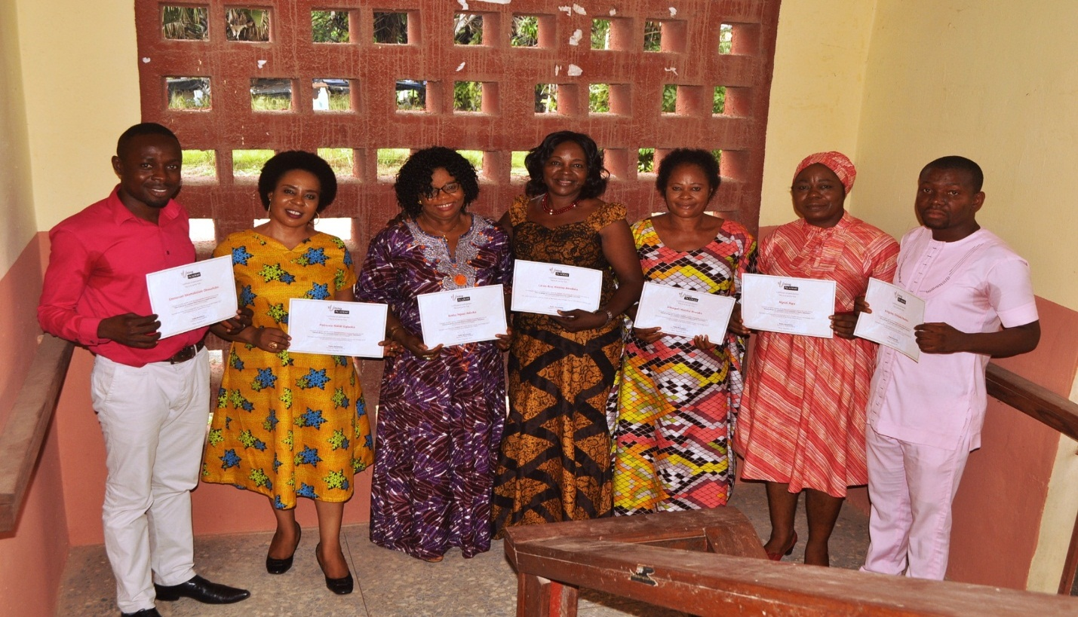

**Lilian-Rita (Centre) pose with her colleagues as they display their TUNING certificates on Course Design for Outcome Based Learning in Higher Education**

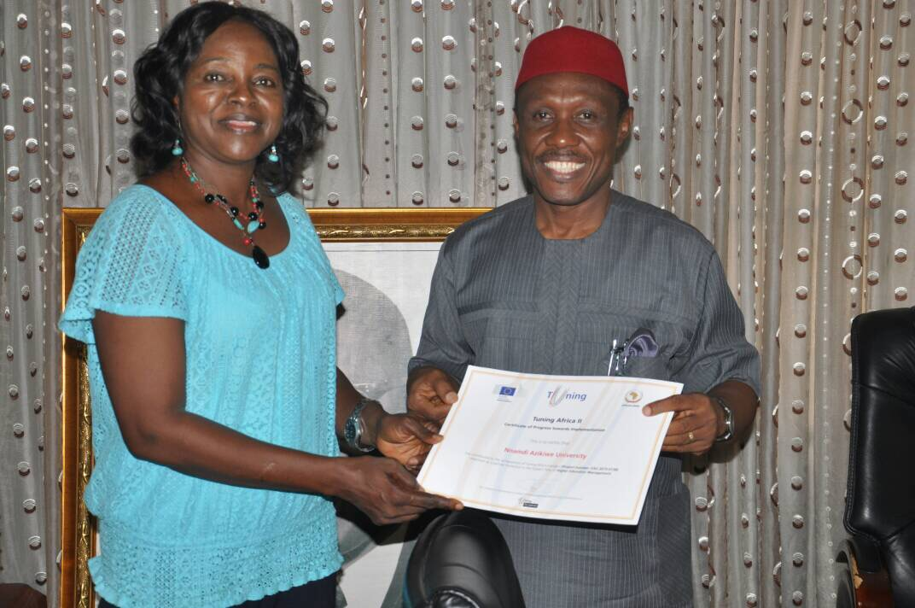

**Lilian-Rita presents to Prof. Joseph Eberendu Ahaneku, the** Vice Chancellor of Nnamdi Azikiwe University Awka, the TUNING Africa II Certificate of Progress towards Implementation.

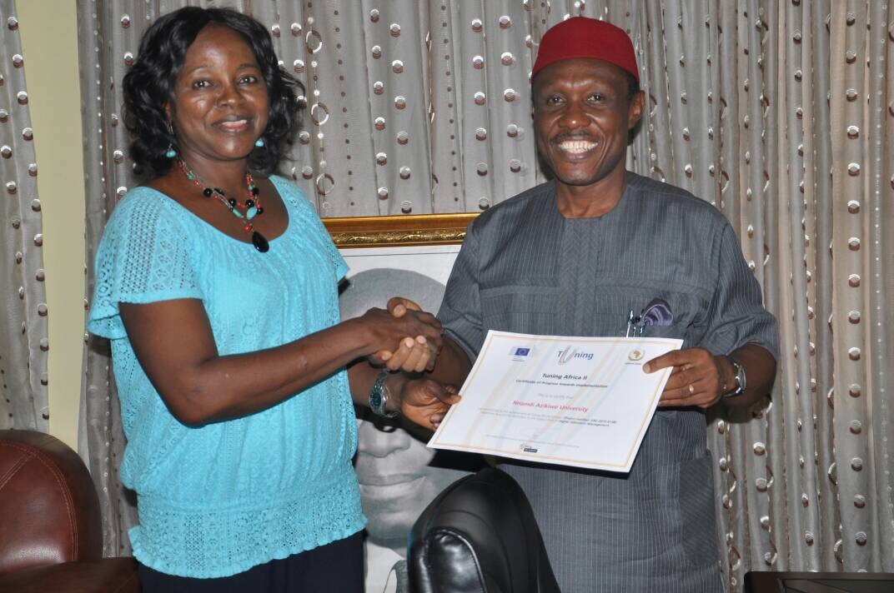

**Lilian-Rita presents to Prof. Joseph Eberendu Ahaneku, the Vice Chancellor of Nnamdi Azikiwe University Awka, the TUNING Africa II Certificate of Progress towards Implementation.**

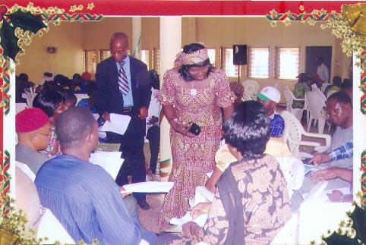

**Lilian-Rita (standing) at a stakeholder consultation on the development of State Education Sector Strategic Plan (SESP) and State Education Sector Operational Plans (SESOP).**

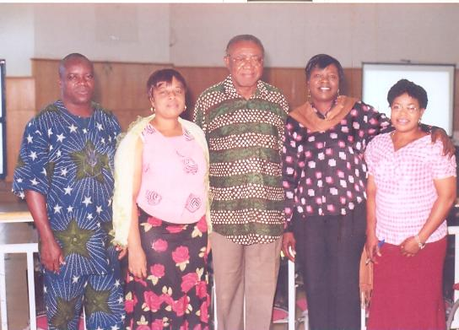

**Lilian-Rita (second from right) pose with Prof. Obanya and team leaders of the team leaders of the State Education Sector Strategic Plan (SESP) and State Education Sector Operational Plans (SESOP) in Ebonyi State.**

